County Councillor Update  Coker Division SCC  Cllr Mark Keating  October 2021 |  | 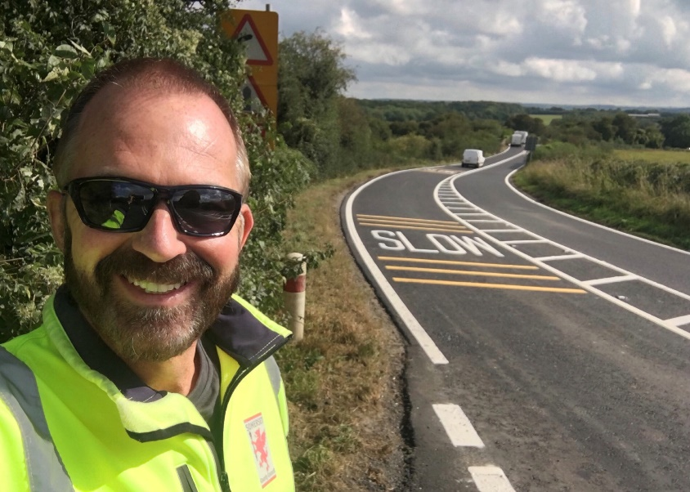
Representing you in - Barwick, Chiselborough, Closworth, East Chinnock, East Coker, Hardington Manderville, Hardington Marsh, Hardington Moor, Haselbury Plucknett, Middle Chinnock, Montacute, North Coker, North Perrott, Norton Sub Hamdon, ​Odcombe, Pendomer, Sutton Bingham, Stoford, West Chinnock, West Coker.
Useful Contacts Resources and Websites: Somerset Coronavirus Support Helpline: 0300 7906275
Cllr Mark Keating – Somerset County Council | E: MAKeating@Somerset.gov.uk | M: 07767 203968
South Somerset Area Highways Office | E: countyroads-southsom@somerset.gov.uk | T: 0300 123 2224
Report Pothole/Road Defect | E: roadsandtransportSD@somerset.gov.uk | T: 0300 123 2224
Report Dead Animal/Mud on Road | E: roadsandtransportSD@somerset.gov.uk | T: 0300 123 2224
Neil McWilliams – Highways Service Manager | E: countyroads-southsom@somerset.gov.uk | T: 0300 123 2224
Lee Norman/Derek Davies – Assist Highways Service Manager | E: countyroads-southsom@somerset.gov.uk | T: 0300 123 2224
Garry Warren/Rebecca Vaughan – Traffic Engineer. Traffic & Transport Development | E: countyroads-southsom@somerset.gov.uk | T: 0300 123 2224
Gully Emptying / Road Sweeper | E: chris.holley@southsomerset.gov.uk | T: 01935 462462
Ranger Scheme |  | T: 01935 462462
Road Records & Highway Licensing | E: Roadrecords@Somerset.gov.uk | T: 0300 123 2224

Report Adult at Risk | adults@somerset.gov.uk |  |  | T: 0300 123 2224  T: Emergency: 999
Report Child at Risk | childrens@somerset.gov.uk |  |  | T: 0300 123 2224  T: Emergency: 999
Children’s Social Care Worker out of hours Emergency Duty Team |  |  |  | T: 0300 123 2327
Fostering and Adoption www.fosteradoptsomerset.org.uk | AandFRecruitmentEnquiryLine@somerset.gov.uk |  |  | T: 0800 587 9900
www.somersetwaste.gov.uk |  | ssdc@southsomerset.gov.uk | T: 01935 462462
https://www.travelsomerset.co.uk/ |  | Travel - Drive Bus Train Walk Cycle Weather
www.somerset.gov.uk |  | generalenquiries@somerset.gov.uk | T: 0300 123 2224
http://roadworks.org/ |  | Useful website for road works info
www.facebook.com/somersetcountycouncil |  | Somerset County Council Facebook page
https://roam.somerset.gov.uk/roam/map |  | Interactive Rights of Way Map / maintenance reporting

Coronavirus infection rates: As of 30th October, the number of confirmed Covid cases in Somerset was 57,072 (33% up from 42,800 on 30th September) and the number of Covid-attributed deaths 872. The rate per 100,000 stands at 709.7 (320.2) for Somerset with Mendip at 853.9 (379.8), Sedgemoor at 653.5 (292.3), South Somerset 668.3 (298.2) and SW&T at 713.0 (321.7). The number of total deaths across the County is currently 12% above the 5-year average and the latest R-value for Somerset is between 0.9 and 1.1.

Infection rates in Somerset continue to be very high. It is therefore important even for those who have had both jabs to remember to observe Social Distancing and to always ventilate indoor areas.

Somerset Coronavirus Support Helpline: A single phone number continues to be available for anyone in Somerset who needs Coronavirus-related support. 0300 790 6275, is open seven days a week from 8am to 6pm.

Vaccination programmes roll-out: Somerset continues to have one of the highest vaccination rates in the country with the latest figures showing over 95.6% of the adult population having had one dose of vaccine and 91.9% having had both doses. Work is focusing on Children aged 12-15 years old and the third booster jab which is due 6 months after the second.

Local Government Reorganisation: Following the Secretary of State for Housing, Communities and Local Government (now renamed Department for Levelling Up, Housing and Communities DLUHC)) decision to support the move to a single Unitary Council across Somerset the transition programme, lead teams and governance structure have been agreed by all Councils. A LGR Joint Committee to oversee the transition has been approved by all five Councils and will sit for the first time on 5th November 2021. It is expected that statutory orders will be available in early November before being laid before Parliament in January 2022 with an agreed vesting date for the new authority as April 2023.

Major investment in infrastructure: Major improvements to the A38 northern corridor heading into Bridgwater are a step closer after the Government approved a £10 million funding bid. Money from the Treasury’s Levelling Up fund will help pay for more than £3.4 million worth of cycling and walking infrastructure along the entire corridor as well as a remodelled Dunball junction and significant improvements to the Canon/Cross Rifles junction. In the same announcement, £5 million was also approved from a separate fund to re-open a train station in Wellington.
Applications for school places 2022: All children starting school for the first time in September 2022, as well as those moving between infant and junior or first and middle school applications must be submitted between Monday 27 September 2021 and Saturday 15 January 2022. www.somerset.gov.uk/admissions
Young Carers Support Survey: The County Council are inviting young carers, their parents/guardians, schools and other professionals working with young carers in Somerset to complete short anonymous surveys by Sunday 21 November in order to gain a better understanding of the services and support provided across the county and how it could be improved. The electronic survey can be accessed via www.somerset.gov.uk/youngcarers (A young carer is anyone under the age of 18 who provides care for another person by taking on practical or emotional responsibilities that would normally be expected of an adult).
Reaching Carbon Zero: Somerset County Council has approved major investment to help save hundreds of tonnes of carbon every year. Earlier this year, SCC successfully bid for £4.1m from the Public Sector Decarbonisation Scheme, to make public buildings more energy efficient. Theis and addition SCC funding will enable decarbonisation projects across several Council owned buildings, including Taunton Library, Yeovil Library, Frome Library, Glastonbury Hub, Milford Infants School, Chilthorne Domer School, and County Hall. Work will include the installation of heat pumps to either replace or supplement existing gas heating systems, replacing windows with double glazing, upgrading building insulation, improving building ventilation systems and installing solar panels. The implementation of these combined schemes is expected to reduce the carbon output of the property estate significantly and move the authority closer to its Carbon Zero target by 2030.
Making streets safer: Funding to help tackle violence against women and girls has been awarded to Somerset County Council. Working with North Somerset, SCC have made a successful joint bid to the Home Office Safer Streets Fund for £324,449. The bid presents an opportunity to work together in tackling Violence Against Women and Girls (VAWG) crimes across the area. The plan sets out a two-tiered approach involving: Prevent – to change behaviour and stop incidents occurring such as VAWG education and awareness in schools, communications campaigns, research and engagement within communities, and Protect – to strengthen the response where incidents are prevalent, such as a safe haven scheme and enhancing the CCTV network and street lighting.
Domestic abuse and modern slavery: New free online resources are available for both professionals and the public to help spot the signs and reduce the risk of becoming a victim of domestic abuse and modern slavery. Members of the public have free access to a set of modules providing guidance on recognising the signs of domestic abuse and modern slavery and what they can do to help. https://somersetsurvivors.org.uk/somerset-survivors/support-for-a-friend-or-family-member/

